**Selected Point Of View in Target System (HFM)**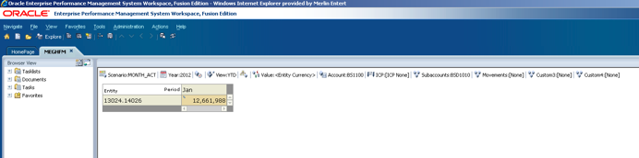

**Error message displayed when selecting Drill Through function.** 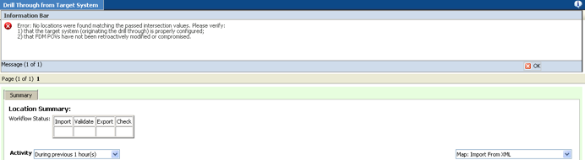

**How the Periods are Mapped in FDM. Refer to column “Target Per (M)”**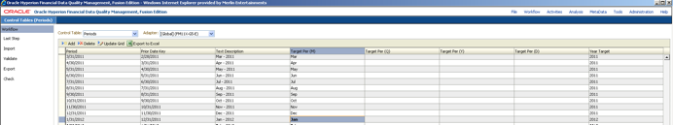

**How Period Jan is setup in HFM. Base Values are set as weekly.**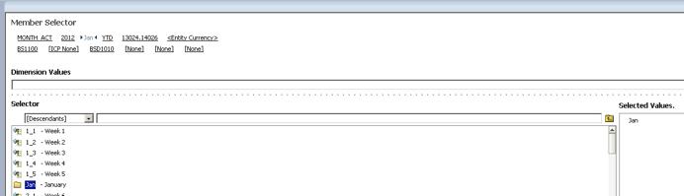

SQL Server Database Table: tPOVPeriodAdaptor – for application MEGSFDMDEV

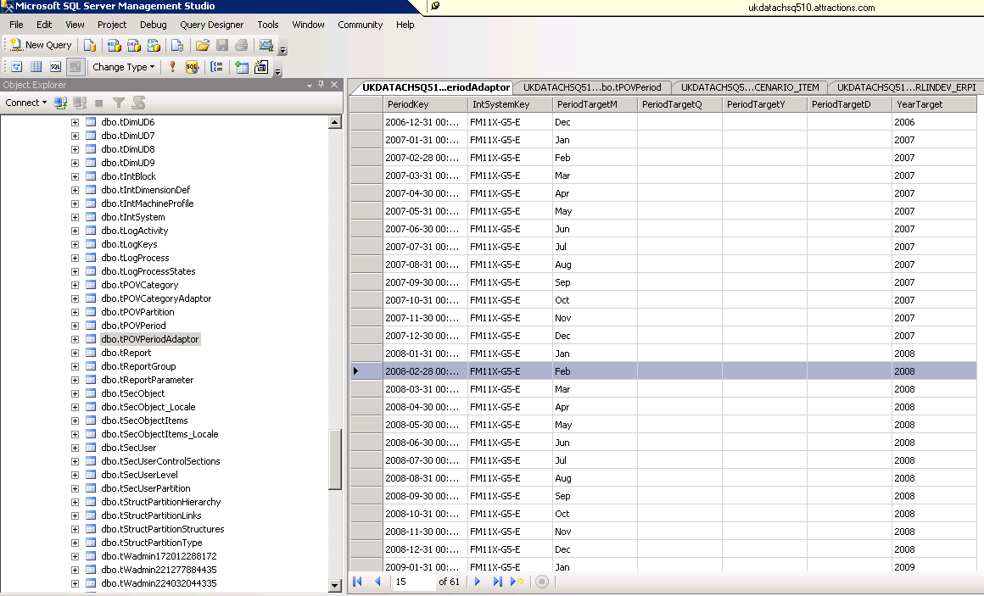

SQL Server Database Table: tPOVPeriodAdaptor – for application FDMWEEKDEV

