Drill Back Production

Update table tPOVPeriodAdaptor

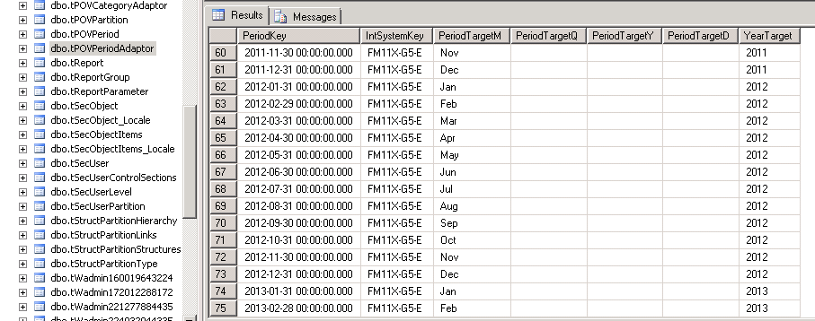

Drill Back Test 1 – Successful

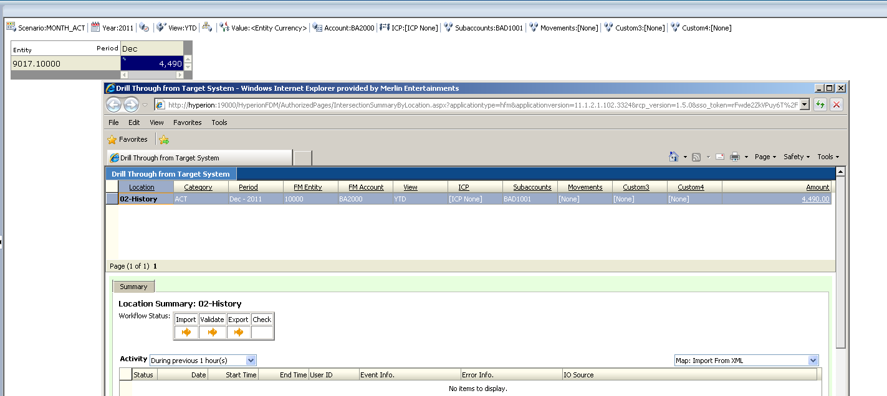

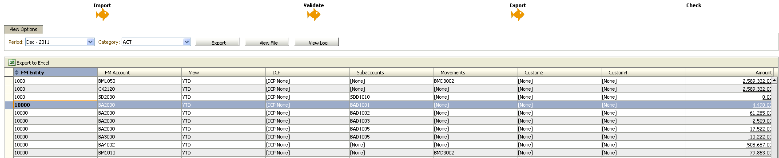

Drill Back Test 2 - Successful

