Click on entity in the point of view at the top of the screen to display the point of view window. Check the filters. I presume your organization is USA so for filter ‘Organisation’ this should be USA.

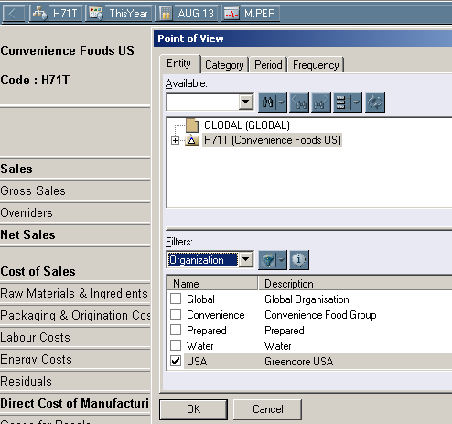

For filter ‘Type’ tick both Parents and Base as shown below.

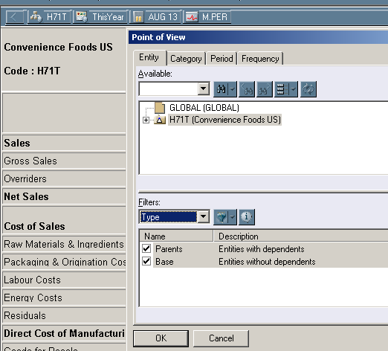

For filter ‘SubEntities’ tick Entities with substructures as shown below.

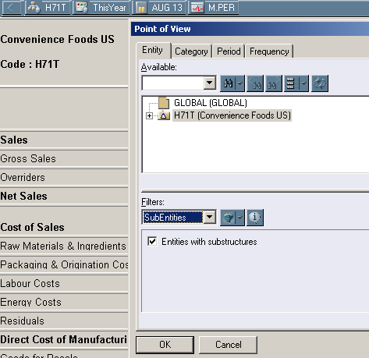

For filter ‘Name’ ensure wildcard specification is set to \*

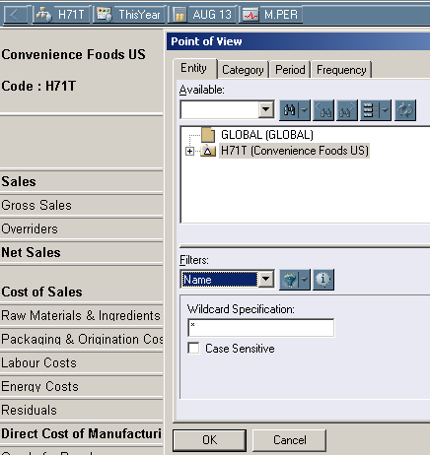

For filter ‘Description’ ensure wildcard specification is set to \*

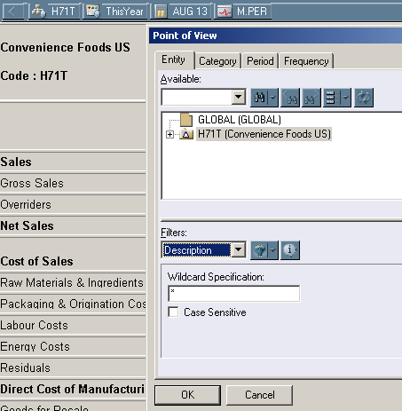

For filter ‘Range’ ensure First and Last are ticked.

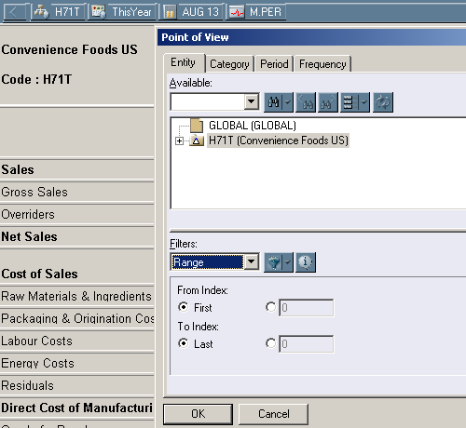

If you cannot see the filters this because they are pushed to the bottom. Change the layout to see the filters as shown below.

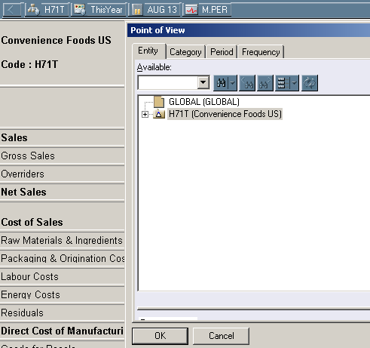

Hold the cursor down on the grey bar on the left and drag it up to the middle of the screen to see the filters.

When you see USA with a plus sign to the left then click the down arrow on the icon shown below and click on Expand All to see all USA entities.

