**Errors when running reports in HFM Workspace – Martin Neumeister 15/03/16**

The errors below appear before the POV selection pops up:

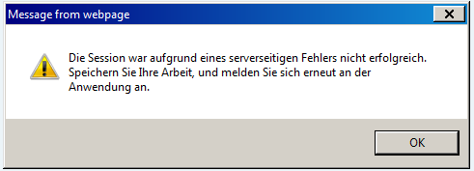

Translation : Due to a server error your session was not successful. Please save your work and log in again.

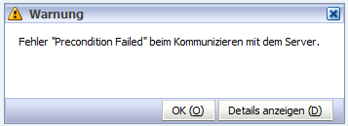

Translation : Error “Precondition failed” when communicating with the server.

